**WORK BREAKDOWN AGREEMENT**

This document is a work breakdown agreement between Amos Choo Jia Shern (31164498)  and Foong Shee Yao(31281125) will serve as a guideline to the delegation of tasks and will be used as a reference to dissolve any matters of dispute between both parties regarding the distribution of work in order to complete Assignment 1, Planning and Design.

Both parties agree to the delegation of work as stated below:

|  |  |
| --- | --- |
| **Members** | **Tasks** |
| Amos Choo Jia Shern | * Construct partial UML class diagram for Grass,Ecopoints,Allosaurs * Construct partial UML sequence diagram for Grass, Ecopoints * Write design rationales for Grass, Ecopoints, Allosaurs * Whoever completed the diagrams last shall helm responsibility of coming up with the final diagram   Assignment 2 Tasks:   * Write design implementations as stated in Design.md * Implementation is according to what is written by the team member himself. Help in implementation shall be provided by the other team member if needed   Assignment 3 Tasks:   * Construct Archaeopteryx,New game map and Thirst behaviour * Help in implementation shall be provided by the other team member if needed |
| Foong Shee Yao | * Construct partial UML class diagram for Hungry Dinosaur and Breeding * Construct partial UML sequence diagram for Hungry Dinosaur, Breeding and Allosaurs * Write design rationales for Hungry Dinosaur and Breeding * Whoever completed the diagrams last shall helm responsibility of coming up with the final diagram   Assignment 2 Tasks:   * Write design implementations as stated in Design.md * Implementation is according to what is written by the team member himself. Help in implementation shall be provided by the other team member if needed   Assignment 3 Tasks:   * Fix previous bugs and construct Agilisaurus, sophisticated Driver features * Help in implementation shall be provided by the other team member if needed |
|  |  |

Both parties also agree to provide assistance to other team members after they have finished their assigned tasks. It is agreed that the documents required for Assignment 1 would be completed at least 1 day before submission so that they can be reviewed for their correctness.

Signed,

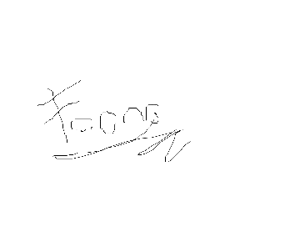

Amos Choo Jia Shern Foong Shee Yao

(Student ID: 31164498) (Student ID:31281125)

Date: 6/10/2020 Date: 6/10/2020